Name: Nafinur Leo

Id: 20-42195-1

Serial Number: 24

CAD[J]

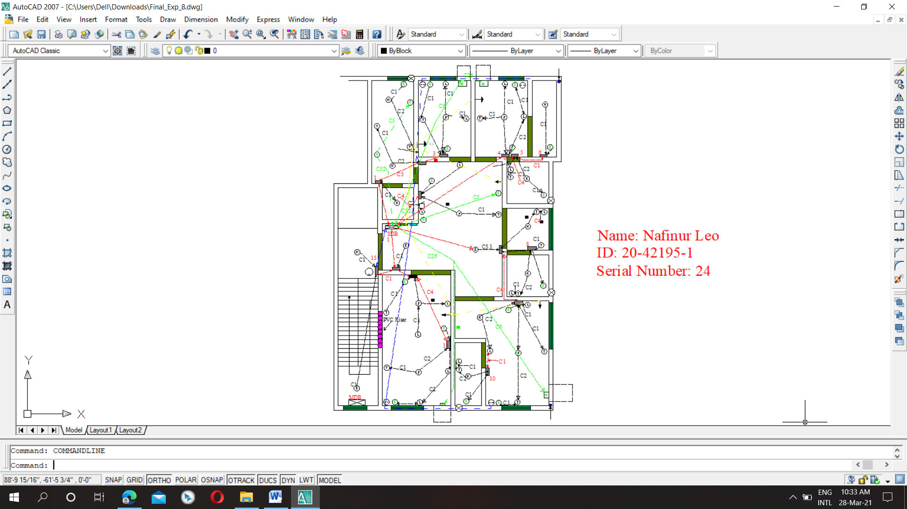

Figure: Conduit Layout – Layer 5 MDB-SDB Connection & Writing for Surge Arrester